**Bullet chart**

* Bullet chart requires 1 dimension and at least 2 measures.
* It is typically used to analyze the sales vs its target or forecast for a particular category.
* It by default provides the 60% and 80% reference w.r.t to target.

Steps:

1. Select 2 measures and a dimension from the field pane.

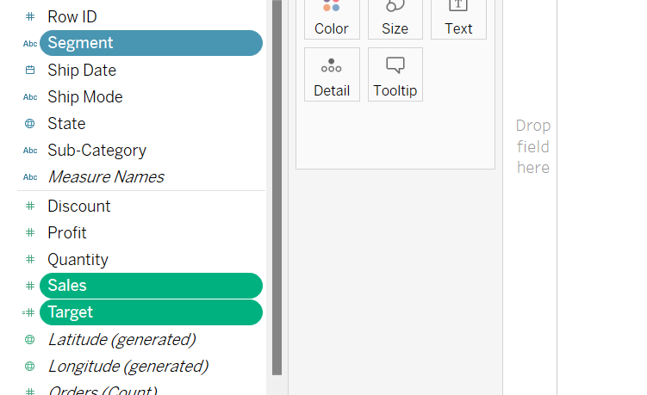

1. Go to the show me option in the top right corner and select Bullet chart.

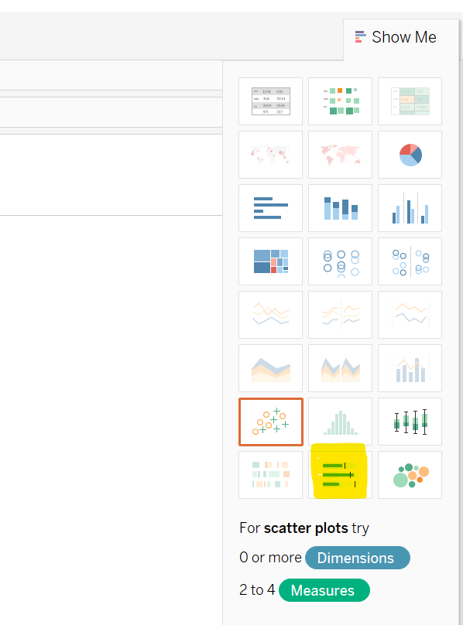

1. You can edit the reference line by clicking on the x-axis and format accordingly.

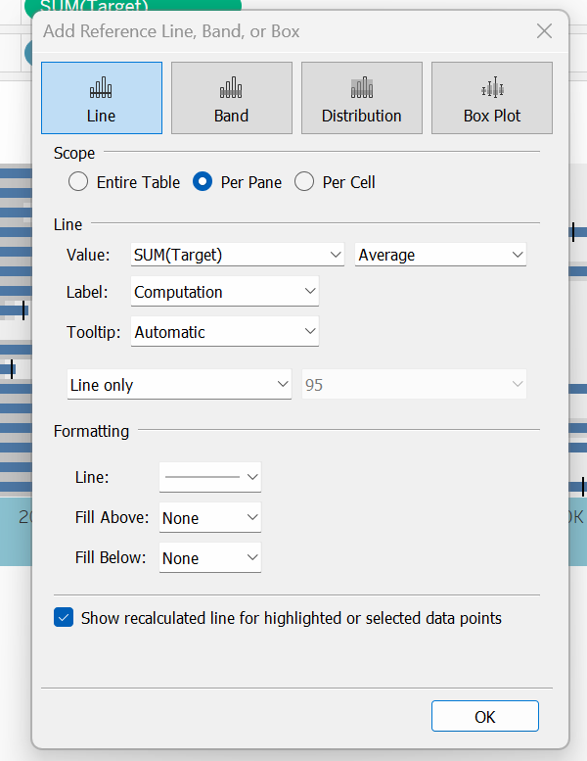

1. 60%-80% line could be changed from below dialog box.

